Helping companies strengthen their bottom line by investing in social and environmental good | Logo | Supporting NGOs to build corporate and foundation partnerships that extend their impact and funding

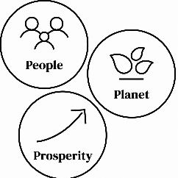
Corporate Sustainable Impact strategy, planning, and execution
Helping companies build impact strategies and plans, and execute them to support business goals, community needs, supply chain resilience, and employee engagement. Incorporating data to define and track social, environmental, and commercial outcomes.

  Multi-stakeholder impact partnerships  Helping companies, NGOs, and foundations identify and vet partners in the US, globally, and in communities. Together, designing partnerships that align interests, strengthen implementation, and achieve measurable results. |   SMEs Sustainability Standards Advisory  Helping small and mid-sized companies select and implement credible sustainability standards that match their size, sector, capacity, customers, investors, and growth plans.
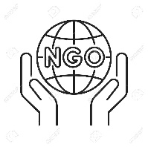  Corporate and Foundation Partnerships for NGOs  Helping NGOs identify and structure corporate and foundation partners that align with their values. To cultivate and manage long-term relationships that generate revenue, deepen mission impact, and diversify funding. | 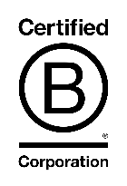  B Corp Readiness and Certification  Helping companies understand B Corp requirements, assess readiness, close gaps, organize documentation, and manage the certification or recertification process in accordance with B Lab standards.

PRODUCTS

Strategy Sprint

Readiness Assessment

Fractional Advisory Support

Implementation Support

Proposal and Partnership Development

Impact Measurement and Reporting

Staff Training and Organizational Capacity Building

FOUNDER

Ms. ABCDE is a social impact consultant with 25 years of senior leadership experience helping companies, NGOs, foundations, and small businesses connect strategy to measurable results.

Before launching her practice, she held senior roles at Pact, MEDA, and the State University of New York's Center for International Development, working across 40 countries. She has helped organizations raise more than $200 million from corporate, foundation, and government funders, including partnerships with the Mastercard Foundation, the Gates Foundation, Chevron, IKEA, and Walmart. She also designed and facilitated more than 365 multi-stakeholder partnerships for USAID across 93 countries and authored a USAID-commissioned partnership effectiveness tool that was formally adopted across its partner network.

Her sustainability experience includes GRI reporting, human rights due diligence frameworks aligned with UN and OECD standards, and hands-on B Corp certification support, including completing the full B Impact Assessment process and B Lab's official certification courses. Her sector experience spans agri-food supply chains, mangrove conservation, agricultural capacity building, and community livelihoods across Africa, Asia, Latin America, and Southeast Asia.

She teaches graduate-level coursework on private sector social impact at American University and the State University of New York, where she covers corporate motivation, partnership strategy, shared value, partnership development, and impact measurement.

